**Name of Report:** Student Balance till date greater than zero.

**Navigation:** Student Financial-> Cashiering -> Balance by business day -> Review Receipt Tender Flow

**Filter used: 1-**Academic Program (eg-MBA01) **2-** Term (eg-1301)

**Screenshot:**

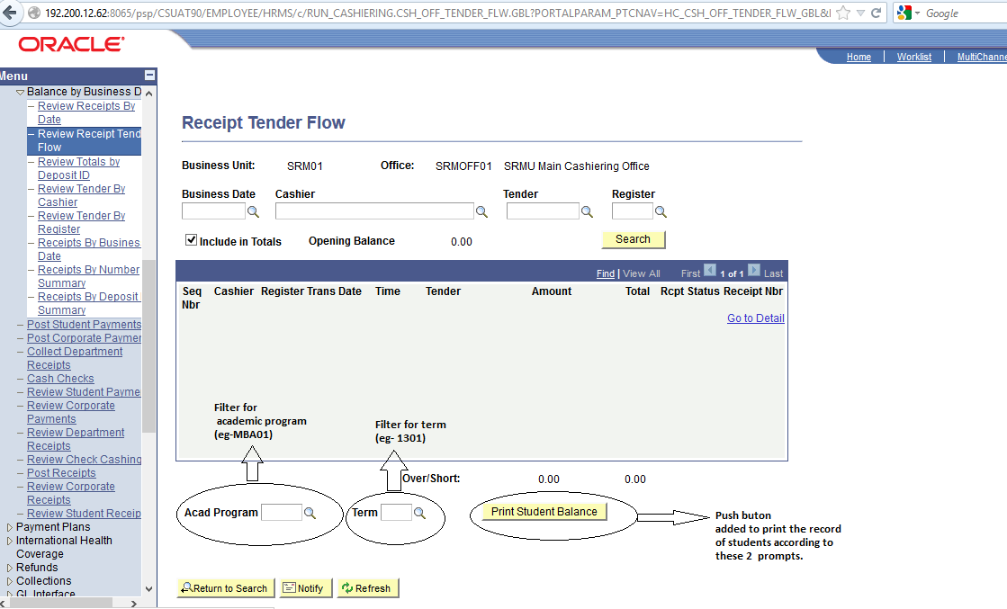

**P.S. -** Attached pdf file which is printed and shows the report.